Worksheet 1a: Module 4/ Day 2: A “Business Houses and Parts”—to be filled in for it Stages.
Business Stage Number and Name:____________________________________Business Chart Type:__________________________________
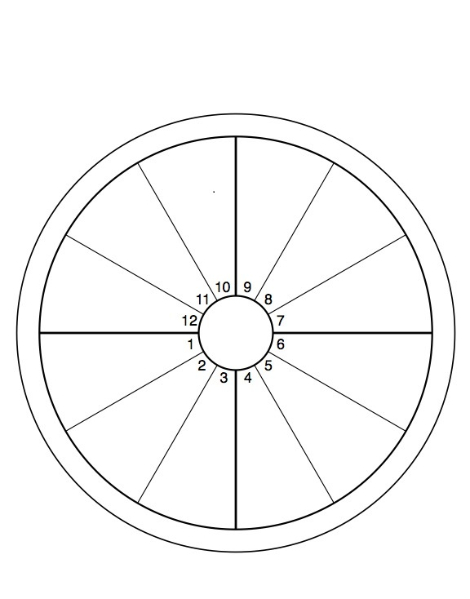
Business Parts: * Business Image and Description * Financial * Products and Services * Marketing * Relations: 1. Communications 2. Alliances 3. Social role (public) * Time Management & Metrics * Spiritual * Day to Day Operations * Entrepreneurship * Creative * Educational * Goals & Mission * Foundation * Management

10 Management
9. Higher Business
Education
12. Hidden Resources
Relations 3
11. Social Role
6. Day to Day
Operations
8. Shared Partnerships
Interests
Relations 2
7. Alliances
5. Creativity
4. Foundation
Relations 1.
3. Communications
2. Financial
1. Image

